**Lab 3**

**Objectives:**

The objectives of the above three tasks focus on enhancing web development skills through practical application of HTML and CSS. The first task aims to design a structured layout for an e-commerce website using external CSS for better styling and organization. The second task emphasizes creating a visually appealing and well-structured table using only div elements, leveraging internal CSS for effective formatting. The third task involves crafting a user-friendly form using external CSS, encouraging customization of colors and fonts to create an aesthetically pleasing design. Overall, these tasks aim to strengthen knowledge of CSS integration and its role in creating professional web designs.

**Q.1. Create the following layout for your ecommerce website using external CSS.**

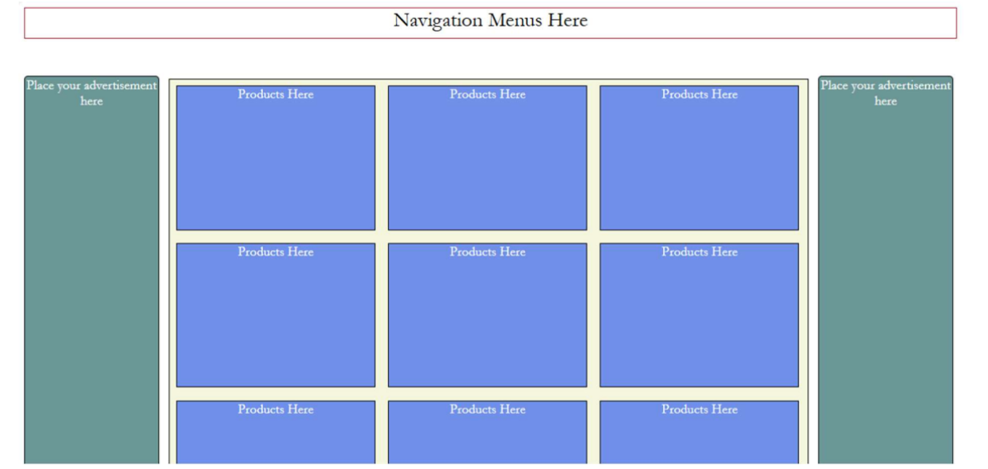

**HTML Tag Attributes**

1. <!DOCTYPE html>: Declares the document as HTML5.
2. <html lang="en">: Sets the document language to English.
3. <title>: Displays the page title in the browser tab.
4. <link rel="stylesheet" href="ecommerce.css">: Links an external CSS file.
5. <header class="navigation">: Defines the header section with a "navigation" class.
6. <div class="container">: Creates a container for layout structure.
7. <aside class="advertisement left">: Adds a left advertisement section.
8. <main class="product-grid">: Contains the main product grid layout.
9. <aside class="advertisement right">: Adds a right advertisement section.
10. <div class="product">: Represents individual product items.

**CSS Attributes**

1. *: Resets margins, padding, and box-sizing.
2. body: Sets the font to Arial for the document.
3. .navigation: Styles the navigation bar with color, alignment, and borders.
4. .container: Defines a flex container with spacing.
5. .advertisement: Styles advertisement sections with color, width, and alignment.
6. .product-grid: Creates a grid layout for products with spacing and styling.
7. .product: Styles products with color, padding, and text alignment.

**Source Code:**

**ecommerce.html:**

<!DOCTYPE *html*>

<html *lang*="en">

<head>

    <title>E-commerce Layout</title>

    <link *rel*="stylesheet" *href*="ecommerce.css">

</head>

<body>

    <header *class*="navigation">

        Navigation Menus Here

    </header>

    <div *class*="container">

        <aside *class*="advertisement left">

            Place your advertisement here

        </aside>

        <main *class*="product-grid">

            <div *class*="product">Products Here</div>

            <div *class*="product">Products Here</div>

            <div *class*="product">Products Here</div>

            <div *class*="product">Products Here</div>

            <div *class*="product">Products Here</div>

            <div *class*="product">Products Here</div>

            <div *class*="product">Products Here</div>

            <div *class*="product">Products Here</div>

            <div *class*="product">Products Here</div>

        </main>

        <aside *class*="advertisement right">

            Place your advertisement here

        </aside>

    </div>

</body>

</html>

**ecommerce.css**

* {

    margin: 0;

    padding: 0;

    box-sizing: border-box;

}

body {

    font-family: Arial, sans-serif;

}

.*navigation* {

    background-color: #fae5d3;

    text-align: center;

    padding: 10px;

    font-size: 18px;

    border: 2px solid #ccc;

    margin: 25px;

}

.*container* {

    display: flex;

    margin: 25px;

}

.*advertisement* {

    background-color: #27ae60 ;

    color: #333;

    width: 15%;

    text-align: center;

    padding: 5px;

    border: 1px solid #ccc;

}

.*advertisement*.*left* {

    margin-right: 5px;

}

.*advertisement*.*right* {

    margin-left: 5px;

}

.*product-grid* {

    display: grid;

    grid-template-columns: repeat(3, 1fr);

    gap: 20px;

    flex-grow: 1;

    border: 1px solid #ccc;

    background-color: #2874a6 ;

    padding: 20px;

}

.*product* {

    background-color: #85c1e9;

    color: #fff;

    text-align: center;

    padding: 90px 90px;

    border: 1px solid #ccc;

    font-size: 16px;

}

**Output:**

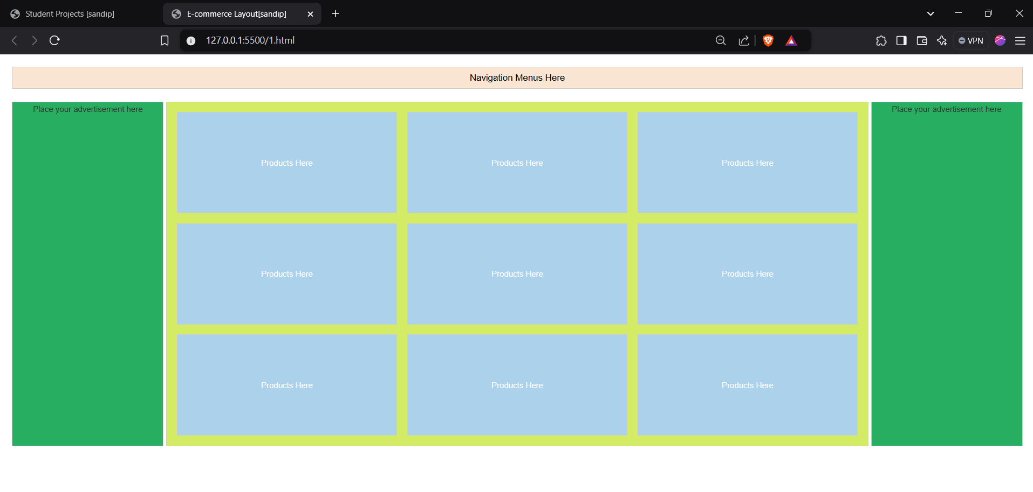

**Q.2. Create a Table with project details using only divs. You may take reference from the practical session of Lab 1 table. Make use of internal CSS.**

**HTML Structure**

1. <!DOCTYPE html>: Declares the document type as HTML5.
2. <html lang="en">: Specifies the language of the document as English.
3. <title>: Sets the title of the document as "Student Projects."
4. <h1>: Displays the page title, "Student Projects," centered at the top.
5. . table-container: Wraps the entire table with a border and rounded corners.
6. . row. Header: Defines the table header with column titles (S.N, Project Name, etc.) styled in green.
7. . row: Represents rows of the table with cells for each column (e.g., student data).
8. . footer: Adds a footer row with the text "End of Projects."

**CSS Styles**

1. body: Applies a light background color, sets the font to Arial, and removes default margins/padding.
2. h1: Centers the heading, with dark text and top/bottom margin for spacing.
3. . table-container: Styles the table with a border, rounded corners, and auto-centered layout.
4. .row: Uses flex for horizontal alignment and consistent row height.
5. . header: Adds a green background, white text, and bold font for the header.
6. . cell: Centers text in each cell with padding, borders, and responsive width.
7. . footer: Styles the footer with a green background and white text, aligning it in the center.

**Source Code:**

**Inlinecss.html:**

<!DOCTYPE *html*>

<html *lang*="en">

<head>

    <title>Student Projects</title>

    <style>

        body {

            font-family: Arial, sans-serif;

            background-color: #f4f4f9;

            margin: 0;

            padding: 0;

        }

        h1 {

            text-align: center;

            margin: 20px 0;

            color: #333;

        }

        .*table-container* {

            width: 90%;

            margin: 0 auto;

            border: 2px solid #333;

            border-radius: 8px;

            overflow: hidden;

        }

        .*row* {

            display: flex;

            height: 100px;

        }

        .*header* {

            background-color: #4CAF50;

            color: #fff;

            font-weight: bold;

        }

        .*cell* {

            border: 1px solid #ddd;

            padding: 20px;

            text-align: center;

            flex: 1;

            justify-content: center; /* *Centers content horizontally* */

            align-items: center; /* *Centers content vertically* */

        }

        .*footer* {

            background-color: #4CAF50;

            color: white;

            text-align: center;

            padding: 10px;

        }

    </style>

</head>

<body>

    <h1>Student Projects</h1>

    <div *class*="table-container">

        <!-- *Header* -->

        <div *class*="row header">

            <div *class*="cell">S.N</div>

            <div *class*="cell">Project Name</div>

            <div *class*="cell">Student Name</div>

            <div *class*="cell">Exam Roll No.</div>

            <div *class*="cell">Remarks</div>

        </div>

        <!-- *Rows* -->

        <div *class*="row">

            <div *class*="cell">1</div>

            <div *class*="cell">Inventory Management System</div>

            <div *class*="cell">Mota bhai </div>

            <div *class*="cell">1001</div>

            <div *class*="cell">Excell ent</div>

        </div>

        <div *class*="row">

            <div *class*="cell">2</div>

            <div *class*="cell">Weather Monitoring App</div>

            <div *class*="cell">Captain marvel</div>

            <div *class*="cell">1002</div>

            <div *class*="cell">Very Good</div>

        </div>

        <div *class*="row">

            <div *class*="cell">3</div>

            <div *class*="cell">Portfolio Website</div>

            <div *class*="cell">Bruce Banner </div>

            <div *class*="cell">1003</div>

            <div *class*="cell">Outstanding</div>

        </div>

        <div *class*="row">

            <div *class*="cell">4</div>

            <div *class*="cell">E-commerce Platform</div>

            <div *class*="cell">Steve jobs </div>

            <div *class*="cell">1004</div>

            <div *class*="cell">Good</div>

        </div>

        <div *class*="row">

            <div *class*="cell">5</div>

            <div *class*="cell">Blog Management System</div>

            <div *class*="cell">Tony Stark</div>

            <div *class*="cell">1005</div>

            <div *class*="cell">Excellent</div>

        </div>

        <!-- *Footer* -->

        <div *class*="footer">

            End of Projects

        </div>

    </div>

</body>

</html>

**Output:**

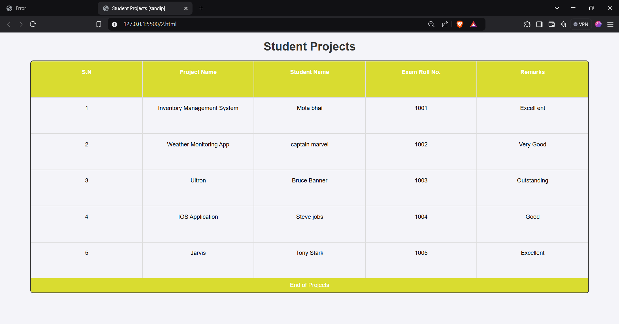

**Q.3. Use external CSS to design the form you created in the 1st Practical Session. The final form should resemble one given below. You may choose the colors and fonts as per your wish.**

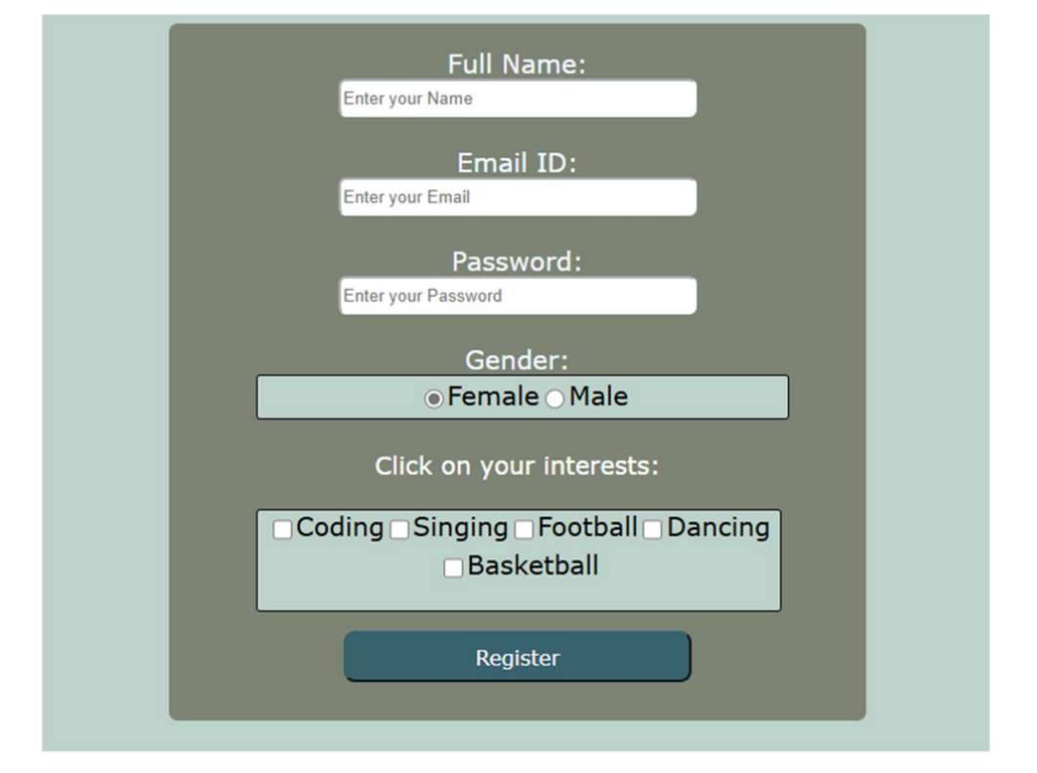

**HTML Structure**

1. <!DOCTYPE html>: Declares the document as HTML5.
2. <html lang="en">: Sets the document language to English.
3. <title>: Defines the title as "Registration Form."
4. <form>: Wraps the registration form content.
5. Input Fields: Includes text, email, password, radio (for gender), and checkbox (for interests).
6. <button>: Adds a "Register" button to submit the form.

**CSS Styling**

1. body: Centers the form using flexbox, sets the font, and applies a yellow background.
2. .form-container: Creates a card-like design with a rounded border, padding, and a box shadow.
3. h2: Adds headings with a small font size and black color.
4. Input Fields: Styled with padding, rounded corners, and a subtle box shadow.
5. .gender & .interests: Centers radio buttons and checkboxes in a styled container with a light background.
6. button: Adds a blue, rounded button that turns red on hover.

**Source Code:**

**form.html:**

<!DOCTYPE *html*>

<html *lang*="en">

<head>

    <title>Registration Form</title>

    <link *rel*="stylesheet" *href*="form.css">

</head>

<body>

    <div *class*="form-container">

        <form>

            <h2>Full Name:</h2>

            <input *type*="text" *placeholder*="Enter your Name" *required*>

<h2>Email ID:</h2>

            <input *type*="email" *placeholder*="Enter your Email" *required*>

            <h2>Password:</h2>

            <input *type*="password" *placeholder*="Enter your Password" *required*

            <h2>Gender:</h2>

            <div *class*="gender">

                <label><input *type*="radio" *name*="gender" *value*="Female"> Female</label>

                <label><input *type*="radio" *name*="gender" *value*="Male"> Male</label>

            </div>

            <h2>Click on your interests:</h2>

            <div *class*="interests">

                <label><input *type*="checkbox" *name*="interest" *value*="Coding"> Coding</label>

                <label><input *type*="checkbox" *name*="interest" *value*="Singing"> Singing</label>

                <label><input *type*="checkbox" *name*="interest" *value*="Football"> Football</label>

                <label><input *type*="checkbox" *name*="interest" *value*="Dancing"> Dancing</label>

                <label><input *type*="checkbox" *name*="interest" *value*="Basketball"> Basketball</label>

            </div>

            <button *type*="submit">Register</button>

        </form>

    </div>

</body>

</html>

**form.css:**

body {

    font-family: Arial, sans-serif;

    background-color:#f9e79f;

    display: flex;

    justify-content: center;

    align-items: center;

    height: 100vh;

    margin: 0;

}

.*form-container* {

    background-color:#f5b041;

    border-radius: 15px;

    padding: 25px;

    width: 360px;

    box-shadow: 0px 4px 6px rgba(0, 0, 0, 0.1);

    text-align: center;

}

form {

    display: flex;

    flex-direction: column;

    gap: 15px;

}

h2 {

    font-size: 16px;

    color: black;

    margin-bottom: 5px;

}

input[*type*="text"],

input[*type*="email"],

input[*type*="password"] {

    width: 100%;

    padding: 8px;

    border: none;

    border-radius: 5px;

    box-shadow: 0px 2px 4px rgba(0, 0, 0, 0.1);

    margin-bottom: 10px;

    text-align: center;

}

.*gender*,.*interests* {

    display: flex;

    justify-content: center;

    align-items: center;

    background-color: #fdf2e9; /* *Updated background color* */

    padding: 10px;

    border-radius: 10px;

    gap: 10px;

}

label {

    font-size: 14px;

    color: #333;

}

button {

    background-color: #2e86c1;

    color: white;

    border: none;

    padding: 20px;

    border-radius: 70px;

    cursor: pointer;

    font-size: 16px;

    text-align: center;

}

button:*hover* {

    background-color: red;

}

**Output:**

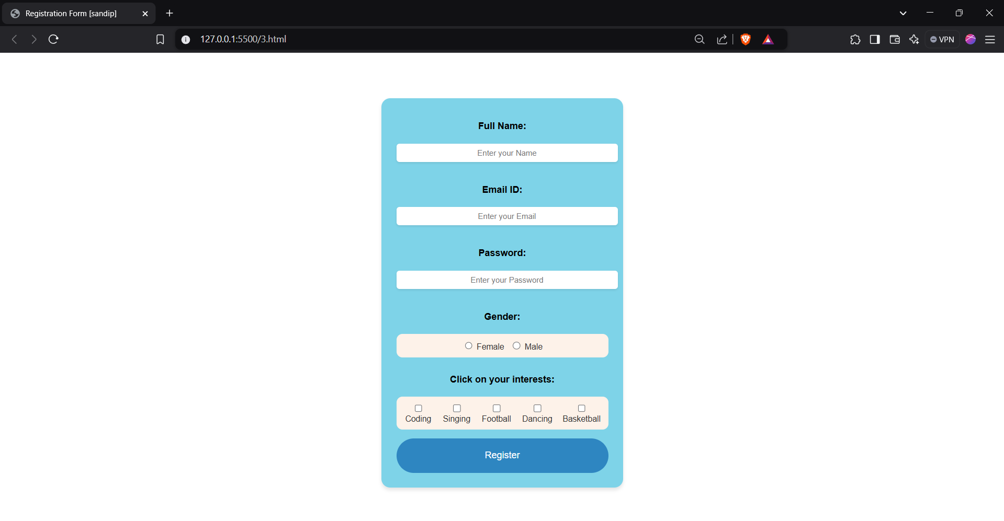

**Conclusion:**

In conclusion, these tasks provide hands-on experience in utilizing HTML and CSS to design functional and visually appealing web components. By creating an e-commerce layout, a table using div elements, and a customized form, students develop essential skills in structuring web pages and applying external and internal CSS effectively. These exercises promote creativity and encourage attention to detail while adhering to web design principles. Ultimately, the tasks prepare students to build professional-grade websites with enhanced usability and aesthetic appeal. This practical approach reinforces theoretical knowledge and bridges the gap between learning and real-world application.